35.3: a) For constructive interference the path diference is 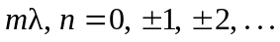 The separation between sources is 5.00 m, so for points between the sources the largest possible path difference is 5.00 m. Thus only the path difference of zero is possible. This occurs midway between the two sources, 2.50 m from A.
b) For destructive interference the path difference is 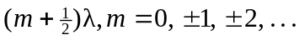
A path difference of 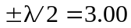 m is possible but a path difference as large as 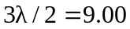m is not possible. For a point a distance x from A and 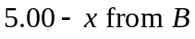 the path difference is
